

DVTK Design Specification
Definition Library
1.0
2005-06-29

Table of Contents
1 Introduction 6
1.1 Purpose 6
1.2 Scope 6
1.3 Audience 6
1.4 Abbreviations and acronyms 6
1.5 References 6
1.6 History 6
2 Definition concepts 8
3 Definition File concepts 9
3.1 Standard Definition Files 9
3.2 Private Definition Files 9
3.3 Special Definition Files 9
4 Global Design of Definition component 10
4.1 Systems and Application Entities 10
4.2 SOP Classes & datasets 10
4.3 Modules, Macro's, Attributes and values 11
5 Detail Design of Definition Attribute Group Class 12
5.1.1 Managing the conditions for a attribute, module or macro 12
5.1.2 Get the attribute in a Definition Attribute group 13
5.1.3 Managing the macro in a IOD 13
5.1.4 Setting/Getting the Module usage in a IOD 13
6 Detail Design of Definition Attribute class 15
6.1.1 Managing the VM of a Attribute 15
6.1.2 Managing the conditions for a attribute 16
6.1.3 Setting/Getting the name of a attribute 16
6.1.4 Setting/Getting the Second VR of a attribute 16
7 Detail Design of System and Application Entities classes 17
7.1 System Class 17
7.1.1 Setting/Getting the name of a system 17
7.1.2 Setting/Getting the version of a system 17
7.1.3 Managing the AEs in a system 17
7.2 AE Session Class 18
7.2.1 Setting/Getting the name of an AE 18
7.2.2 Setting/Getting the version of an AE 18
7.3 AE Definition Class 19
7.3.1 Setting/Getting the name of a system 19
7.3.2 Setting/Getting the version of a system 19
7.3.3 Managing the definition file instances in an AE 19
7.3.4 Managing the Meta SOP classes in an AE 20
7.3.5 Managing the SOP classes in an AE 20
7.3.6 Managing the Dataset in an AE 20
8 Detail Design of Meta SOP and SOP definition classes 21
8.1 Meta SOP Definition Class 21
8.1.1 Getting the UID of a Meta SOP class 21
8.1.2 Getting the name of a Meta SOP class 21
8.1.3 Managing the SOP classes in a Meta SOP class 21
8.1.4 Managing the SOP classes in a Meta SOP class 21
8.2 SOP Definition Class 22
8.2.1 Getting the UID of a SOP class 22
8.2.2 Getting the name of a SOP class 22
8.2.3 Managing the Dataset/Macro in a SOP class 22
9 Detail Design of Definition File classes 24
9.1 Definition File Content Class 24
9.1.1 Setting/Getting the System properties 25
9.1.2 Setting/Getting the AE properties 25
9.1.3 Setting/Getting the Meta SOP class properties 25
9.1.4 Adding/Getting the SOP class properties 25
9.1.5 Adding the command definition 25
9.1.6 Getting the dataset 25
9.1.7 Registering/ Un-registering the definition file content 25
9.2 Definition Class 26
9.2.1 Installation/ Un-installation of single definition file content 27
9.2.2 Registering the SOP class details 27
9.2.3 Managing the Systems information 27
9.2.4 Managing the AEs information 27
9.2.5 Managing the Meta SOP class information 27
9.2.6 Managing the SOP class information 27
9.2.7 Managing the Attribute information 27
9.2.8 Managing the Recognition code information 28
9.2.9 Managing the Defined terms information 28
9.2.10 Populating the attributes 28
9.3 Definition Detail class 28
9.3.1 Setting/Getting the name of an AE 28
9.3.2 Setting/Getting the version of an AE 28
9.3.3 Setting/Getting the name of the SOP class 28
9.3.4 Setting/Getting the UID of the SOP class 29
9.3.5 Setting/Getting the confirmation of the Meta SOP class 29
9.4 Definition File class 29
9.4.1 The definition file is loaded or not 29
9.4.2 Loading of a definition file 29
9.4.3 Unloading of a definition file 29
9.4.4 Getting the details of a definition file 30
9.5 Definition Instance class 30
9.5.1 Getting the definition file name 30
9.5.2 Getting the definition file content 30
9.5.3 Managing the reference index for a definition file in a instance of DVT 30
10 Detail Design of Definition DICOM object class 31
10.1 Setting/Getting the DICOM object name 31
10.2 Setting/Getting the DIMSE command 31
10.3 Managing the modules in a DICOM object 31
10.4 Getting the attribute in a DICOM object 32
11 Conditions component 33
12 Detail Design of Condition class 34
12.1 Setting the primary condition 34
12.2 Setting the secondary condition 34
12.3 Getting the result of conditions after evaluation 34
12.4 Evaluate the condition 34
13 Detail Design of Condition Node class 35
13.1 Managing the result messages 35
13.2 Evaluate the condition 35
14 Condition Binary Node class 36
14.1 Setting/Getting the Left node 36
14.2 Setting/Getting the Right node 36
14.3 Evaluate the condition 36
15 Detail design of Condition Binary node class 37
15.1 CONDITION_AND_NODE_CLASS 37
15.1.1 Evaluate the condition 37
15.2 CONDITION_OR_NODE_CLASS 37
15.2.1 Evaluate the condition 37
15.3 CONDITION_VALUE_NODE_CLASS 38
15.3.1 Evaluate the condition 38
15.3.2 Getting the referred attribute 38
15.3.3 Getting the value number indicated in definition file 38
15.4 CONDITION_LESS_NODE_CLASS 38
15.4.1 Evaluate the condition 38
15.5 CONDITION_LESS_EQ_NODE_CLASS 38
15.5.1 Evaluate the condition 38
15.6 CONDITION_EQ_NODE_CLASS 39
15.6.1 Evaluate the condition 39
15.7 CONDITION_GREATER_EQ_NODE_CLASS 39
15.7.1 Evaluate the condition 39
15.8 CONDITION_GREATER_ NODE_CLASS 39
15.8.1 Evaluate the condition 39
16 Condition Unary Node class 41
16.1 Setting/Getting the condition node 41
16.2 Evaluate the condition 41
17 Detail design of Condition Unary node class 42
17.1 CONDITION_EMPTY_ NODE_CLASS 42
17.1.1 Evaluate the condition 42
17.2 CONDITION_PRESENT_ NODE_CLASS 42
17.2.1 Evaluate the condition 43
17.3 CONDITION_NOT_ NODE_CLASS 43
17.3.1 Evaluate the condition 43
17.4 CONDITION_NAVIGATION_ NODE_CLASS 43
17.4.1 Evaluate the condition 43
17.4.2 Navigate to the node 44
17.4.3 Get the navigated node 44
17.5 CONDITION_NAVIGATION_HERE_NODE_CLASS 44
17.5.1 Navigate the node 44
17.6 CONDITION_NAVIGATION_UP_NODE_CLASS 44
17.6.1 Navigate the up node 44
17.7 CONDITION_NAVIGATION_DOWN_NODE_CLASS 44
17.7.1 Navigate the down node 44
17.7.2 Getting the group 44
17.7.3 Getting the element 45
17.8 CONDITION_NAVIGATION_TAG_CLASS 45
17.8.1 Navigate the down node 45
17.8.2 Getting the group 45
17.8.3 Getting the element 45
18 Condition Leaf class 46
18.1 Evaluate the leaf 46
19 Detail design of Condition Leaf class 47
19.1 CONDITION_LEAF_CONST_CLASS 47
19.1.1 Evaluate the leaf 47
19.2 CONDITION_LEAF_VALUE_NR_CLASS 47
19.2.1 Evaluate the leaf 47
19.3 CONDITION_LEAF_TRUE_CLASS 48
19.3.1 Evaluate the leaf 48
Appendix A Definition File Format Reference 49

Introduction

Purpose
This document describes the global and detail design of the DICOM Definition component. This is a living document and changes in the design should be laid down in this document. Especially the sections on detailed design Definition classes may change during the project.

Scope
The Definition library provides DICOM specific knowledge to the DICOM Validation Tool to enable a validation. This library defines classes used to describe the main data structure used by the DICOM Validation Tool.

Audience
This document is intended for all the implementers in the DVT project. The reader is assumed to have basic DICOM knowledge.

Abbreviations and acronyms
Abbreviation / acronym | Description
AE | Application Entity
Definition File | File containing the DICOM SOP Class description(s).
DVT | DICOM Validation Tool.
Session File | File containing the test session parameters.
User | Person who is implementing the Definition library.
IOD | Information Object Definition
VM | Value Multiplicity
VR | Value Representation

References
Reference | Title | Author/Publisher | Document number
DEFINITION | Definition File Specification | M. van Minderhout | XZS 980-000123.00
SCRIPT | DICOMScript Language Specification | R. Busbridge | XZS 980-000118.00
DESIGNSPEC | DICOM object design specification | R. Busbridge  M. van Minderhout | XZS 980-000183.01
PATTERNS | Design Patterns | E. Gamma et al. | ISBN 0201633612
DCM | DICOM standard 2004 | NEMA | PS 3.0-2004

History
Version | Date | Author | Description
0.1 | 06 May 2005 | Piyush Bhageriya  Manisha Singla | Initial version
1.0 | 29 June 2005 | Piyush Bhageriya  Manisha Singla | Update for OpenSource release.

Definition concepts
The Definitions component takes care of the storage of the DICOM definitions. The definitions are used during validation, data import and scripting. The definitions are provided by means of definition files, which contain a definition per SOP Class. During parsing of these files an internal data structure is built.

The Definitions component provides the interfaces for consulting the definitions in terms of following information:
- Getting value representation, name of an Attribute.
- Getting the defined term or enumerated values of an Attribute.
- Getting the condition specified for Modules, Attributes and Macro's.
- Getting the recognition code details for Private attributes.
This interface is independent from the format in which the definitions were provided. Currently the definition file format as described in [DEFINITION] is used. However in the future other means of supplying the definitions could be used, for example an XML file or stream.

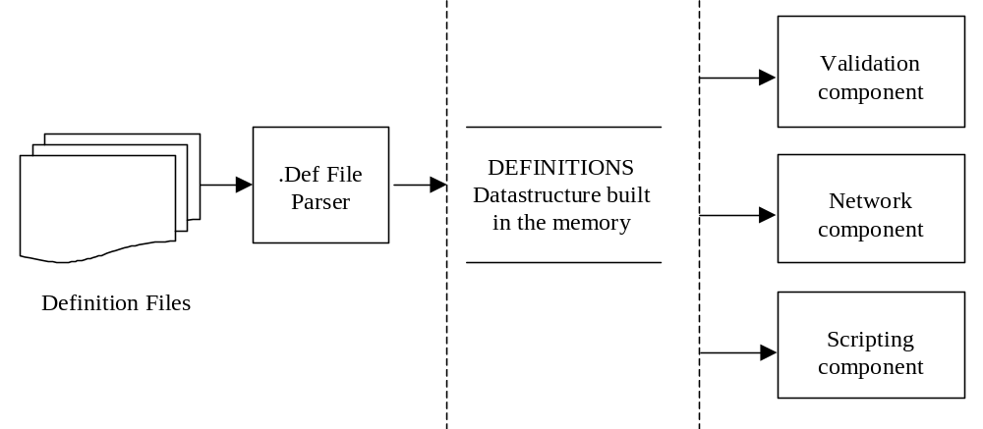
Figure 1 Definition relationship diagram

Definition File concepts
A Definition File (.DEF) describes a single DICOM (Meta) SOP Class in terms of the combination of DIMSE Commands and IODs that make up the (Meta) SOP Class. The combination of DIMSE Commands and IODs is taken from the DICOM standard, parts 3, 4 and 7 [DCM].
The definition files are ASCII text files and can be modified by user. The Definition File format can formally be described in Backus-Naur Form (BNF)(Appendix A Definition File Format Reference). The Lex/yacc parser should be written for parsing the definition files.
There are three types of definition files as described below:

Standard Definition Files
It is the Definition Files, which define DIMSE Commands and IOD’s specific to each SOP class directly taken from the DICOM Standard - parts 3 and 4.

Private Definition Files
The User can customize Definition Files for any Private SOP Classes by taking one of the Standard Definition Files as a template. Private UID’s, Modules and Attributes can be defined. The Module/Attribute requirements can be made stricter, conditionals can become Mandatory, but never make the requirements more relaxed

Special Definition Files
There are several special definition files provided and used by DVT. These are used during media validation and mentioned below.
DicomDirSpecial.def - used for Media creation and validation.
FileMeta.def – file Meta information.

Global Design of Definition component
The definition data structure is built from the classes, which are based on DICOM terms. The main class is a DEF_DEFINITION_CLASS, which is based on the singleton pattern [PATTERNS], page 127. The singleton pattern ensures the definition class only has one instance and provides a global point of access to it.

Systems and Application Entities
As it may necessary to store definitions of different systems simultaneously, in the definition warehouse the data is organized per system, per Application Entity, per SOP Class. Default the system is the DICOM standard, specified via a pseudo system name and a pseudo Application Entity. One Application Entity class can contain one or more reference of the Meta SOP/SOP class so it maintains the reference of the DEF_INSTANCE_CLASS.
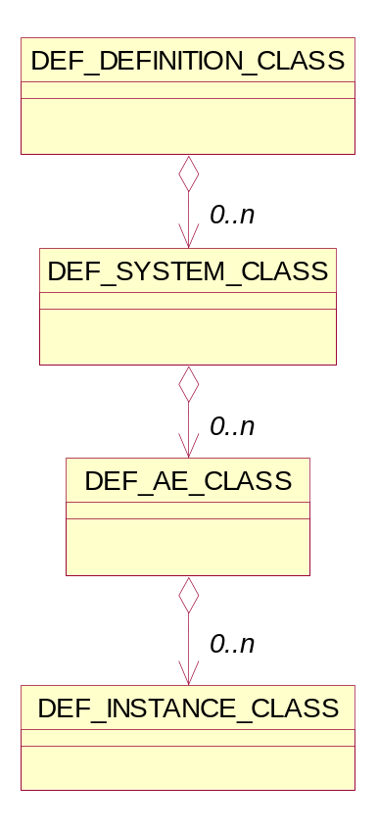
Figure 2 Definition Component Class diagram

SOP Classes & datasets
Each SOP Class maintains lists of references to defined dataset objects and command-set objects. The command and dataset objects are derived classes from a base class: DEF_DICOM_OBJECT_CLASS. This has advantages from a validation point of view. The DEF_DICOM_OBJECT_CLASS is module oriented. As command objects in DICOM don't have a module structure a pseudo module has to be created for command objects.

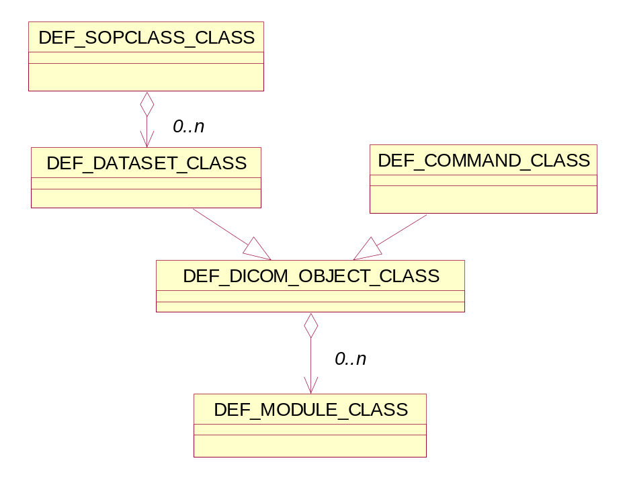
Figure 3 SOP Class – Definition DICOM Object relationship

Modules, Macro's, Attributes and values
In DICOM a module contains attributes and possibly macros. A macro is a group of attributes and macros can be nested. Further more sequence attributes contain items, which in turn also contain attributes and possibly macros. To be able to benefit from the similarities between these different attribute groups a base class DEF_ATTRIBUTE_GROUP_CLASS is defined. For attribute group operations as addAttribute and addMacro are common. An attribute may have multiple values (distinguished via a value number) and for each value number multiple defined or enumerated values can be specified. DEF_ATTRIBUTE_CLASS is derived from ATTRIBUTE_CLASS and keep the references to VALUES_LIST_CLASS objects. The VALUES_LIST_CLASS maintains a list of possible values the attribute can have. The value type classes are derived from a BASE_VALUE_CLASS in the same way as is done for the DICOM objects.
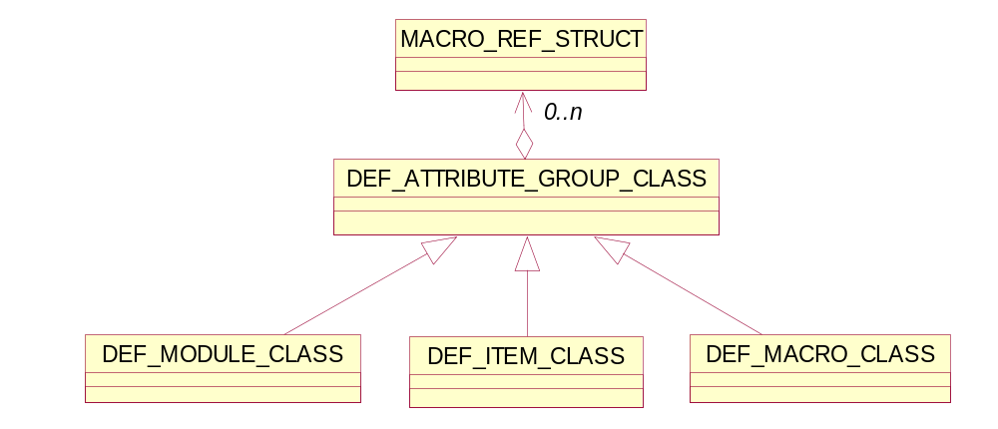
Figure 4 Definition Attribute Group class

Detail Design of Definition Attribute Group Class
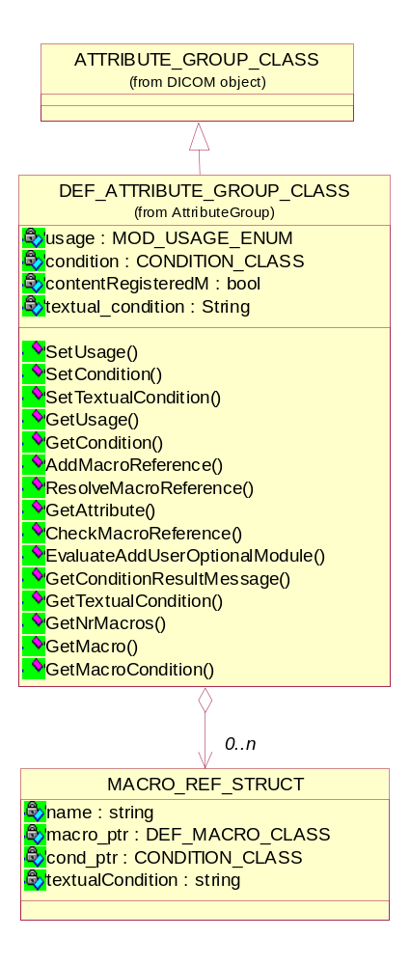
Figure 5 Definition Attribute group class

Managing the conditions for a attribute, module or macro
Condition can be specified for Modules, Attributes and Macro's and are used to relate the presence of an attribute (or module or macro) to the presence and/or value(s) of other attribute(s).
- Setting/Getting the condition for a attribute, module
void SetCondition(CONDITION_CLASS*);
CONDITION_CLASS* GetCondition();
This is the method to get/set the conditions. All types of conditions are implemented by class CONDITION_CLASS Ref 11.

- Setting/Getting the textual condition for a attribute, module
void SetTextualCondition(const string);
string GetTextualCondition();

- Getting the condition for a Macro
CONDITION_CLASS* GetMacroCondition(UINT);
string GetMacroTextualCondition(UINT);

- Getting the result of the condition
string GetConditionResultMessage();
When an attribute or a macro has a conditional type (1C, 2C, 3C or C) the condition of an attribute or macro needs to be checked to determine the actual type of the attribute for validation. So there is two types of condition results are defined: TRUE and FALSE.
When the result is TRUE the attribute or macro type changes from 1C, 2C, 3C or C to respectively 1, 2, 3 or M.
When the condition result is FALSE the attribute may not be present in the object.

Get the attribute in a Definition Attribute group
DEF_ATTRIBUTE_CLASS* GetAttribute(UINT);
DEF_ATTRIBUTE_CLASS* GetAttribute(UINT, UINT);
DEF_ATTRIBUTE_CLASS* GetAttribute(UINT, UINT, DEF_MACRO_CLASS*);
This is the method to get the attribute with a given index, tag.
The third overload searches for the attribute in the specified macro. This is necessary as it is possible that attribute definitions are different in different macro's.

Managing the macro in a IOD
- Get the indexed macro in a IOD
DEF_MACRO_CLASS* GetMacro(UINT);

- Get the nr of macros in a IOD
int GetNrMacros();

- Managing the macro reference in a attribute group
void AddMacroReference(const string, CONDITION_CLASS*, const string);
void ResolveMacroReference(const string, DEF_MACRO_CLASS*);
bool CheckMacroReferences();

Setting/Getting the Module usage in a IOD
Module is a set of Attributes within an Information Entity or Normalized IOD, which are logically related to each other.
An IOD contains number of modules, in which some modules are mandatory and some are conditional or user optional. The module usage enum contains the type of usability of a particular module in an IOD e.g. mandatory, conditional or user optional.
- Setting the Module usage in a IOD
void SetUsage(const MOD_USAGE_ENUM);

- Getting the Module usage in a IOD
MOD_USAGE_ENUM GetUsage();

Detail Design of Definition Attribute class
The Definition attribute class knows everything about a single attribute defined under a definition attribute group: group, element, VR, VM and condition for the attribute. For each of these values, functions are available to set and get the value.
The Definition attribute class is derived from the ATTRIBUTE_CLASS will be implemented as an array of abstract BASE_VALUE_CLASS. There can be zero, one or more elements in the array depending on how many values the attribute has. A “zero-length” attribute will have no values.
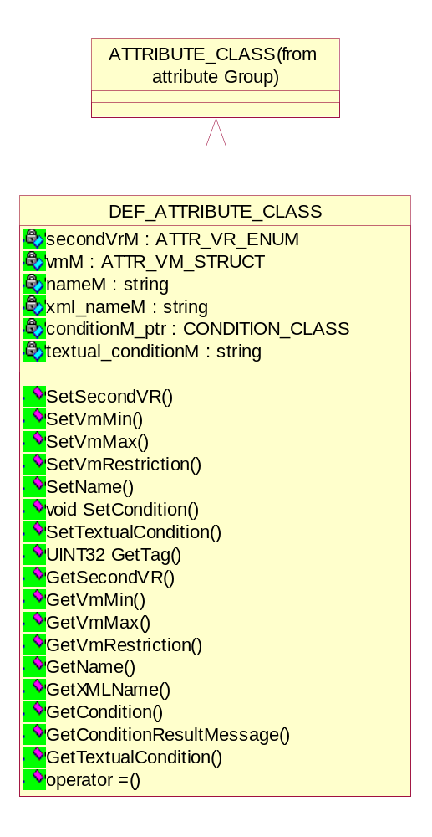
Figure 6 Definition Attribute class

Managing the VM of a Attribute
The VM of a attribute specifies the number of values that can be encoded in the Value Field of that attribute.

- Setting/getting the min/max value multiplicity of an attribute
void SetVmMin(UINT min);
void SetVmMax(UINT max);
void GetVmMin();
void GetVmMax();

- Setting/getting the value multiplicity restriction on an attribute
void SetVmRestriction(ATTR_VM_RESTRICT_ENUM restriction);
ATTR_VM_RESTRICT_ENUM GetVmRestriction();
The ATTR_VM_RESTRICT_ENUM restricts the VM of an attribute to double or triple means that attribute can contain only two or three values.

Managing the conditions for a attribute
- Setting/Getting the condition for a attribute
void SetCondition(CONDITION_CLASS *cond_ptr);
CONDITION_CLASS* GetCondition();
This is the method to get/set the conditions. All types of conditions are implemented by class CONDITION_CLASS Ref 11.

- Setting/Getting the textual condition for a attribute, module
void SetTextualCondition(const string);
string GetTextualCondition();

- Getting the result of the condition
string GetConditionResultMessage();

Setting/Getting the name of a attribute
- Setting/Getting the name of a attribute
void SetName(const string name);
string GetName();
string GetXMLName();

Setting/Getting the Second VR of a attribute
Some attributes can have a second VR.
- Setting/Getting the Second VR of a attribute
void SetSecondVR(ATTR_VR_ENUM vr);
ATTR_VR_ENUM GetSecondVR();

Detail Design of System and Application Entities classes

System Class
The system represents the System Under Test (SUT) or DVT. The system can contain one or more AEs. The default system is the DICOM standard, specified via a pseudo system name and a pseudo Application Entity e.g. DICOM 3.0.
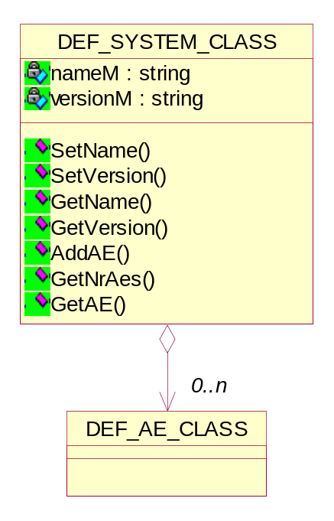
Figure 7 System Class diagram

Setting/Getting the name of a system
void SetName(const string);
string GetName();

Setting/Getting the version of a system
void SetVersion(const string);
string GetVersion();

Managing the AEs in a system
- Get the particular AE in the system
DEF_AE_CLASS* GetAE(UINT);
DEF_AE_CLASS* GetAE(const string, const string);
DEF_AE_CLASS* GetAE(const string);

- Get the nr of AEs in the system
UINT GetNrAes();

- Add the particular AE in the system
void AddAE(DEF_AE_CLASS*);

AE Session Class
Any test in the DVT executes in the context of an AE session. The AE session is identified by the AE name and version. The default AE title and version is “DICOM 3.0”.
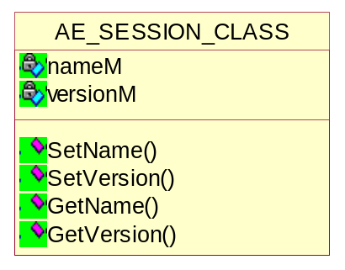
Figure 8 AE Session Class diagram

Setting/Getting the name of an AE
void SetName(const string);
string GetName();

Setting/Getting the version of an AE
void SetVersion(const string);
string GetVersion();

AE Definition Class
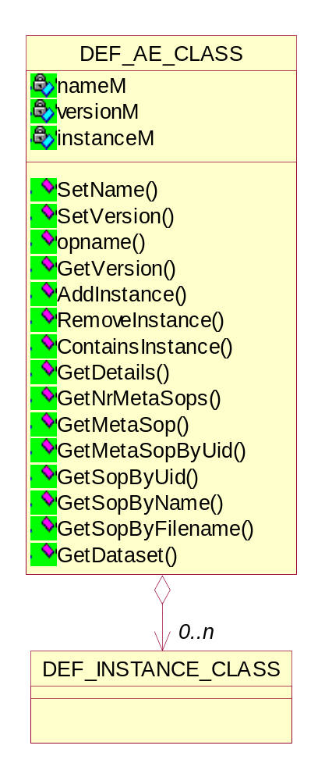
Figure 9 AE Class diagram

Setting/Getting the name of a system
void SetName(const string);
string GetName();

Setting/Getting the version of a system
void SetVersion(const string);
string GetVersion();

Managing the definition file instances in an AE
- Add the particular instance in an AE
bool AddInstance(const string, DEF_FILE_CONTENT_CLASS*);

- Remove the particular instance in an AE
bool RemoveInstance(const string);

- Find the particular instance in an AE
bool ContainsInstance(const string);

Managing the Meta SOP classes in an AE
- Get the particular Meta SOP class
DEF_METASOPCLASS_CLASS* GetMetaSop(UINT);
DEF_METASOPCLASS_CLASS* GetMetaSopByUid(const string);

- Get the nr of Meta SOP classes
UINT GetNrMetaSops();

Managing the SOP classes in an AE
- Get the particular SOP class
DEF_SOPCLASS_CLASS* GetSopByUid(const string);
DEF_SOPCLASS_CLASS* GetSopByName(const string);
DEF_SOPCLASS_CLASS* GetSopByFilename(const string);

Managing the Dataset in an AE
- Get the particular SOP class
DEF_DATASET_CLASS* GetDataset(const string);
DEF_DATASET_CLASS* GetDataset(DIMSE_CMD_ENUM, const string);

Detail Design of Meta SOP and SOP definition classes

Meta SOP Definition Class
The Meta SOP Class is a collection of related SOP Classes identified by a single Abstract Syntax UID.

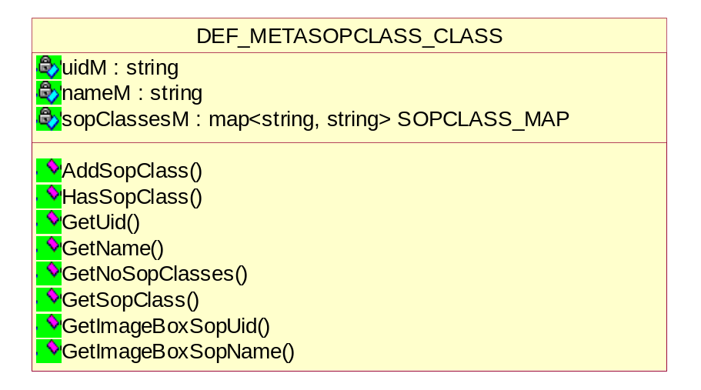
Figure 10 Meta SOP class definition diagram

Getting the UID of a Meta SOP class
inline string GetUid();

Getting the name of a Meta SOP class
inline string GetName();

Managing the SOP classes in a Meta SOP class
- Get the particular SOP class in a Meta SOP class
void GetSopClass(UINT, string&, string&);

- Get the nr of SOP classes in a Meta SOP class
UINT GetNoSopClasses();

- Add the SOP class in a Meta SOP class
void AddSopClass(const string, const string);

- Search for a SOP class in the Meta SOP class
bool HasSopClass(const string);

Managing the SOP classes in a Meta SOP class
- Getting the UID of a Image Box SOP class
string GetImageBoxSopUid();

- Getting the name of a Image Box SOP class
string GetImageBoxSopName();

SOP Definition Class
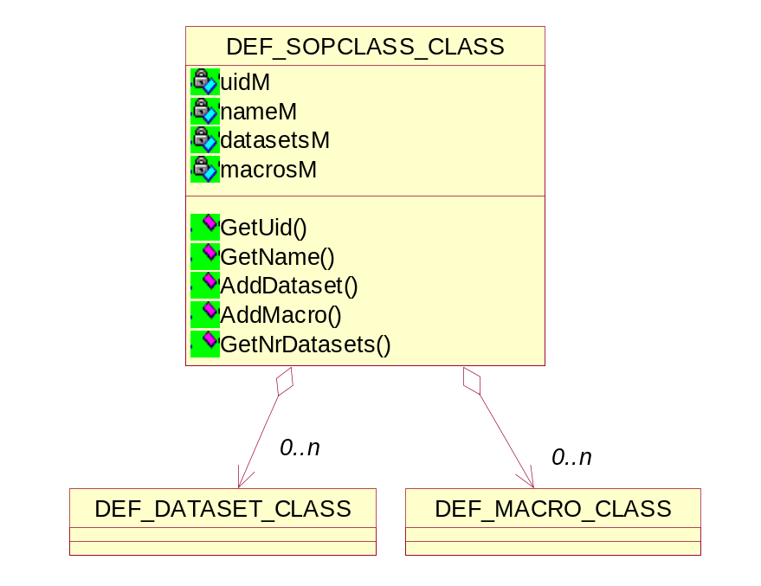
Figure 11 SOP class definition diagram

Getting the UID of a SOP class
inline string GetUid();

Getting the name of a SOP class
inline string GetName();

Managing the Dataset/Macro in a SOP class
- Get the particular Daataset in a SOP class
DEF_DATASET_CLASS* GetDataset(UINT i);
DEF_DATASET_CLASS* GetDataset(DIMSE_CMD_ENUM);
DEF_DATASET_CLASS* GetDataset(const string);
DEF_DATASET_CLASS* GetDataset(const string, DIMSE_CMD_ENUM);

- Get the nr of Datasets in a SOP class
UINT GetNrDatasets();

- Add the Dataset in a SOP class
bool AddDataset(DEF_DATASET_CLASS*);

- Add the Macro in a SOP class
void AddMacro(DEF_MACRO_CLASS*);

Detail Design of Definition File classes

Definition File Content Class
This class is used to set/get the important properties defined in the definition file e.g. System name & version, AE name & version, Meta SOP & SOP class names register the IODs, MACROs and items, sequence attributes etc.
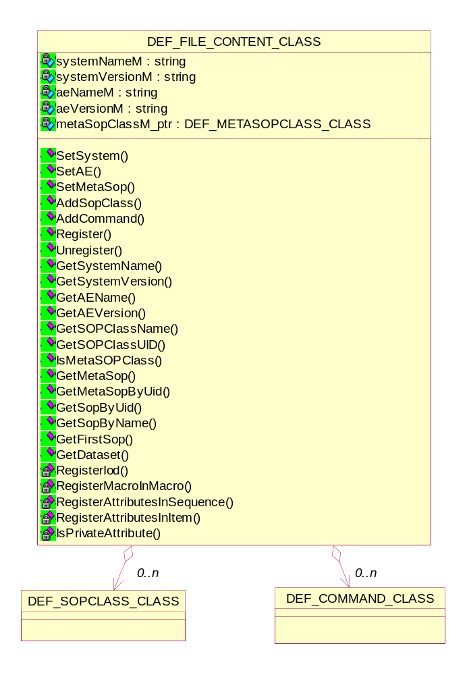
Figure 12 Definition File content class diagram

Setting/Getting the System properties
void SetSystem(const string, const string);
string GetSystemName();
string GetSystemVersion();

Setting/Getting the AE properties
void SetAE(const string, const string);
string GetAEName();
string GetAEVersion();

Setting/Getting the Meta SOP class properties
void SetMetaSop(DEF_METASOPCLASS_CLASS*);
DEF_METASOPCLASS_CLASS* GetMetaSop();
DEF_METASOPCLASS_CLASS* GetMetaSopByUid(const string);

Adding/Getting the SOP class properties
void AddSopClass(DEF_SOPCLASS_CLASS*);
DEF_SOPCLASS_CLASS* GetSopByUid(const string);
DEF_SOPCLASS_CLASS* GetSopByName(const string);
DEF_SOPCLASS_CLASS* GetFirstSop();
string GetSOPClassName();
string GetSOPClassUID();

Adding the command definition
void AddCommand(DEF_COMMAND_CLASS*);

Getting the dataset
DEF_DATASET_CLASS* GetDataset(const string);
DEF_DATASET_CLASS* GetDataset(DIMSE_CMD_ENUM, const string);

Registering/ Un-registering the definition file content
bool Register();
bool Unregister();
This method registers and un-registers the file content into the definition library and makes it available for consultation. The registering operation involves:
- Registration of the Meta SOP class defined in the definition file.
- Registration of all the SOP classes included in the Meta SOP class.
- Registration of the IODs and attributes in each IOD defined in each SOP class.
- Registration of all the DIMSE Commands.
- Registration of all the attributes in nested macros, items and sequences.

This method uses all the private methods for registration of each entity.

Definition Class
This class is a singleton class and provides single instance for definition storage. This class sets all the System, AE, Meta SOP & SOP class information after getting all information by parsing the particular definition file. The lax/yacc parser is used to parse the definition file. The definition file format is shown in Appendix A Definition File Format Reference.
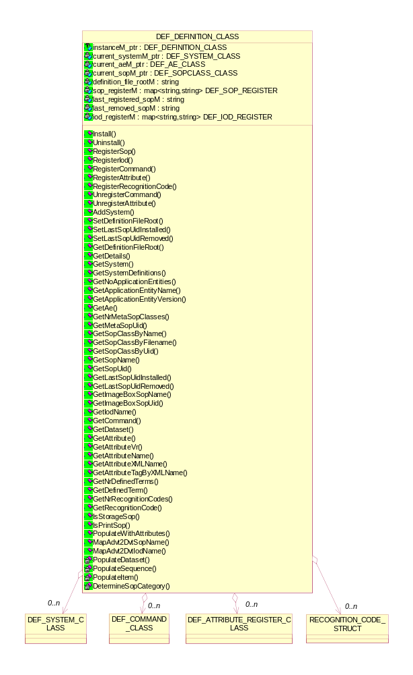
Figure 13 Definition class diagram
The Definition class provides the container for all definition files contents loaded in single instance of DVT and builds all the information in memory. This class provides all public interfaces to access information from other components e.g. validation, network.

Installation/ Un-installation of single definition file content
bool Install(const string, DEF_FILE_CONTENT_CLASS*);
bool Uninstall(const string);
This method runs through the file content and installs its instance also.

Registering the SOP class details
void RegisterSop(const string, const string);
void RegisterIod(const string, const string);
void RegisterCommand(DEF_COMMAND_CLASS*);
void RegisterAttribute(DEF_ATTRIBUTE_CLASS*);
void RegisterRecognitionCode(DEF_ATTRIBUTE_CLASS*);

Managing the Systems information
void AddSystem(DEF_SYSTEM_CLASS*);
DEF_SYSTEM_CLASS* GetSystem(const string, const string);
void GetSystemDefinitions(string*, string*);

Managing the AEs information
UINT GetNoApplicationEntities();
string GetApplicationEntityName(UINT);
string GetApplicationEntityVersion(UINT);
DEF_AE_CLASS* GetAe(const string, const string);
DEF_AE_CLASS* GetAe(const string);

Managing the Meta SOP class information
int GetNrMetaSopClasses();
DEF_METASOPCLASS_CLASS* GetMetaSopClassByUid(const string);
DEF_METASOPCLASS_CLASS* GetMetaSopClass(UINT32);
string GetMetaSopUid(const string);

Managing the SOP class information
DEF_SOPCLASS_CLASS* GetSopClassByName(const string);
DEF_SOPCLASS_CLASS* GetSopClassByName(const string, const string, const string);
DEF_SOPCLASS_CLASS* GetSopClassByFilename(const string);
DVT_STATUS GetSopClassByUid(const string, AE_SESSION_CLASS*, DEF_SOPCLASS_CLASS**);
string GetSopName(const string);
string GetSopUid(const string);
string GetLastSopUidInstalled();
string GetLastSopUidRemoved();

Managing the Attribute information
DEF_ATTRIBUTE_CLASS* GetAttribute(const UINT, const UINT);
ATTR_VR_ENUM GetAttributeVr(const UINT, const UINT);
string GetAttributeName(const UINT, const UINT);
bool GetAttributeXMLName(const UINT, const UINT, string&);
bool GetAttributeTagByXMLName(const string, UINT16&, UINT16&);

Managing the Recognition code information
UINT32 GetNrRecognitionCodes();
void GetRecognitionCode(UINT32, UINT32*, string&);

Managing the Defined terms information
UINT32 GetNrDefinedTerms(DIMSE_CMD_ENUM, const string, UINT32, UINT32 value_nr = 0);
BASE_VALUE_CLASS* GetDefinedTerm(DIMSE_CMD_ENUM, const string, UINT32, UINT32, UINT32 value_nr = 0);

Populating the attributes
bool PopulateWithAttributes(DCM_DATASET_CLASS*, LOG_CLASS*);
This method adds type 2 attributes based on the definition to given dataset.

Definition Detail class
This class is used to set/get the important properties defined in the definition file e.g. AE name & version, Meta SOP & SOP class names etc.
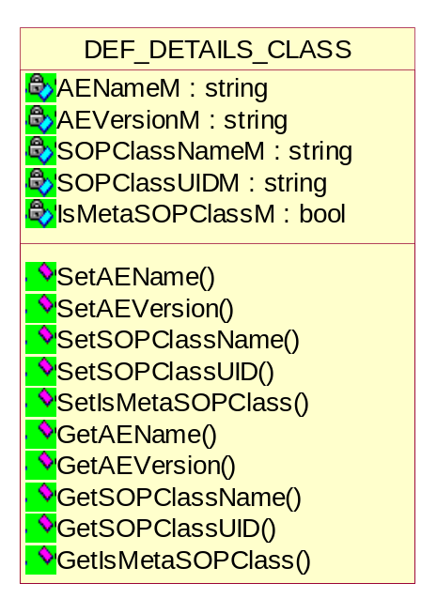
Figure 14 Definition Detail class diagram

Setting/Getting the name of an AE
void SetAEName(const string);
string GetName();

Setting/Getting the version of an AE
void SetAEVersion(const string);
string GetAEVersion();

Setting/Getting the name of the SOP class
void SetSOPClassName(const string);
string GetSOPClassName();

Setting/Getting the UID of the SOP class
void SetSOPClassUID(const string);
string GetSOPClassUID();

Setting/Getting the confirmation of the Meta SOP class
void SetIsMetaSOPClass(bool);
bool GetIsMetaSOPClass();

Definition File class
This class represents the Definition file itself. It derived from BASE_FILE_CLASS and implements the basic definition file operations e.g. loading/unloading of a particular definition file, getting the details of the file etc.
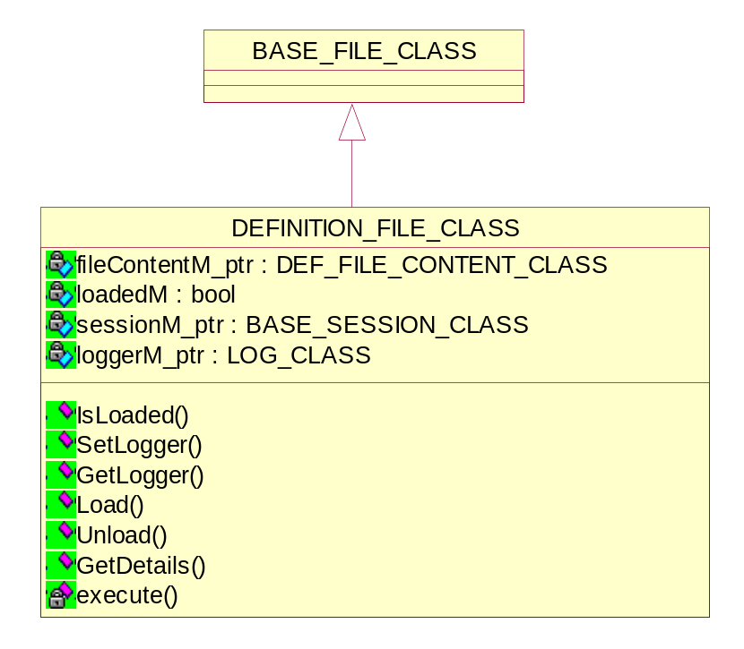
Figure 15 Definition file class diagram

The definition file is loaded or not
bool IsLoaded();

Loading of a definition file
bool Load();

Unloading of a definition file
bool Unload();

Getting the details of a definition file
bool GetDetails(DEF_DETAILS_CLASS&);

Return value | Explanation
true | The operations are successful.
false | The operations are failed.

Definition Instance class
When DVT starts up, it reads all the definition files in memory specified in the Definition directory. User can include one or more definition file paths through DVT so same definition file can be included more than once.
The Definition instance class keeps track of the definition file instances and a reference mechanism is used for this. The reference mechanism makes sure that a definition file read once in memory and avoids the conflicts.
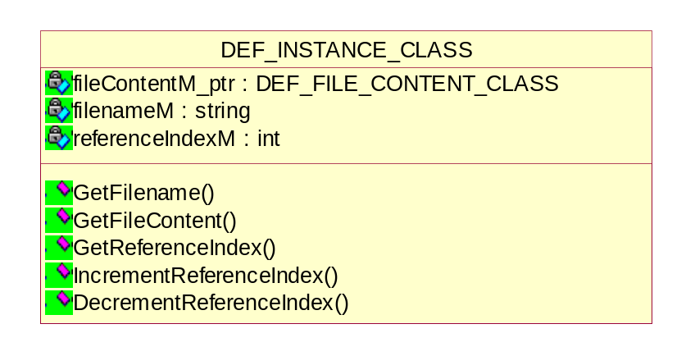
Figure 16 Definition Instance class diagram

Getting the definition file name
string GetFilename();

Getting the definition file content
DEF_FILE_CONTENT_CLASS *GetFileContent();

Managing the reference index for a definition file in a instance of DVT
- Get the reference index for a definition file
int GetReferenceIndex();

- Incrementing/Decrementing the reference index for a definition file
void IncrementReferenceIndex();
void DecrementReferenceIndex();

Detail Design of Definition DICOM object class
This class represents a collection of modules known as DICOM object. The DICOM object may be include modules, macros, DIMSE command or items. These objects are constructed during parsing of a definition file in the memory. The objects are used during validation.
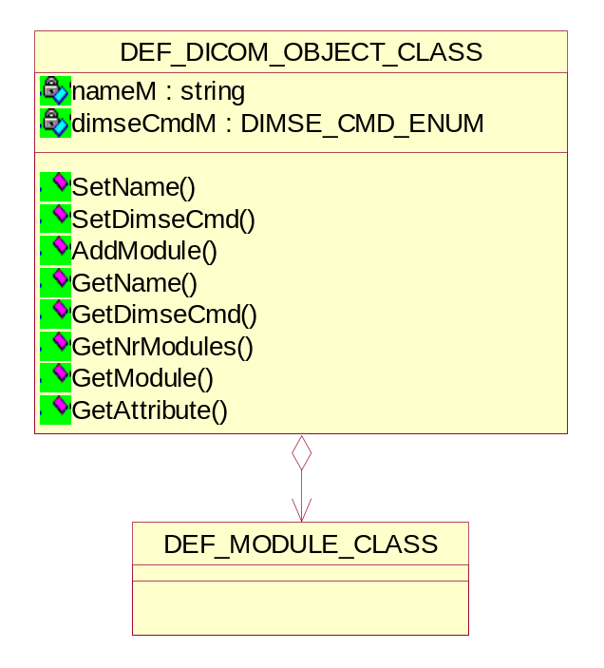
Figure 17 Definition DICOM object class diagram

Setting/Getting the DICOM object name
void SetName(const string name);
string GetName();

Setting/Getting the DIMSE command
void SetDimseCmd(DIMSE_CMD_ENUM dimseCmd);
DIMSE_CMD_ENUM GetDimseCmd();

Managing the modules in a DICOM object
- Getting the module in a DICOM object
DEF_MODULE_CLASS* GetModule(UINT);
DEF_MODULE_CLASS* GetModule(UINT16, UINT16);
The second overload searches for a module containing the requested attribute.
- Adding the module in a DICOM object
void AddModule(DEF_MODULE_CLASS*);

- Getting the nr of modules in a DICOM object
UINT GetNrModules();

Getting the attribute in a DICOM object
- Searching the attribute using group, element nr in the DICOM object definition
DEF_ATTRIBUTE_CLASS* GetAttribute(UINT16, UINT16);
DEF_ATTRIBUTE_CLASS* GetAttribute(string, UINT16, UINT16);

Conditions component
Conditions may be specified for attributes, modules and macros. The conditions are used to relate the presence of an attribute (or module or macro) to the presence and/or value(s) of other attribute(s). The condition syntax is specified in [DEFINITION]. The conditions are implemented via the class structure as depicted in Figure 18.

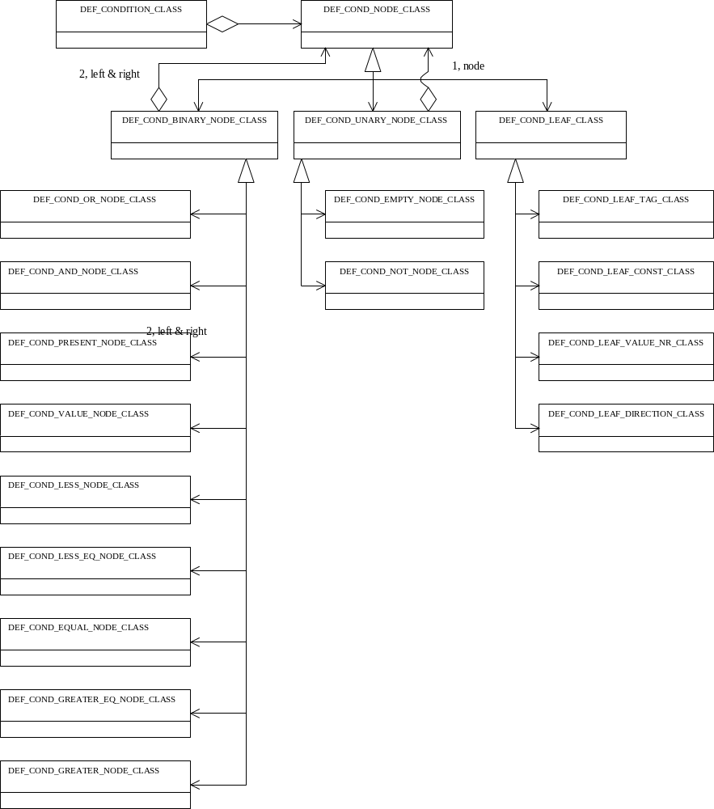
Figure 18 Conditions class diagram

Detail Design of Condition class
This class defines conditions for the DICOM definition files. The conditions can be applied for example for Attributes, Modules, Macro's and Items. All types of conditions defined in [DEFINITION].

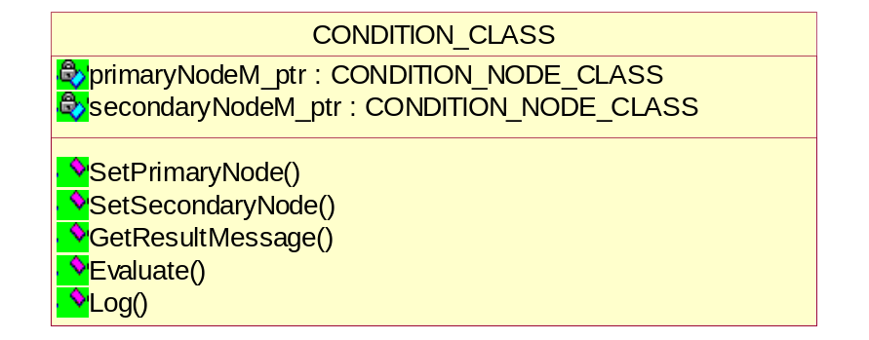
Figure 19 Condition class diagram

Setting the primary condition
void SetPrimaryNode(CONDITION_NODE_CLASS* node_ptr);

Setting the secondary condition
void SetSecondaryNode(CONDITION_NODE_CLASS* node_ptr);

Getting the result of conditions after evaluation
string GetResultMessage();

Evaluate the condition
CONDITION_RESULT_ENUM Evaluate (DCM_ATTRIBUTE_GROUP_CLASS*, DCM_ATTRIBUTE_GROUP_CLASS*, LOG_CLASS*);

Detail Design of Condition Node class
This is the abstract Base Node class and defines a node used for condition specification.

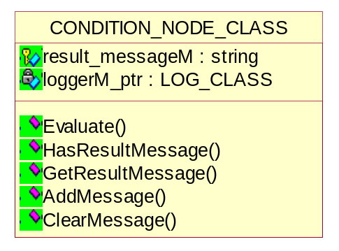
Figure 20 Condition Node class diagram

Managing the result messages
- Checking the existence of result message
bool HasResultMessage();

- Getting the result message
virtual string GetResultMessage();

- Adding the result message
void AddMessage(char* format_ptr, ...);
This method adds message to result message and supports formatting.
- Clearing the result message
void ClearMessage();

Evaluate the condition
virtual bool Evaluate(DCM_ATTRIBUTE_GROUP_CLASS*, DCM_ATTRIBUTE_GROUP_CLASS*, LOG_CLASS*) = 0;

Condition Binary Node class
The condition binary node class represents the conditions that contain two logically related conditions. The primary node represents the normal condition, which is always evaluated. The secondary node represents secondary condition, which is evaluated if present, and the primary condition evaluates false.
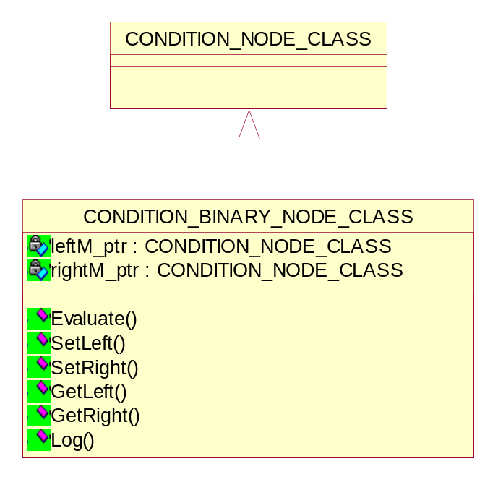
Figure 21 Condition Binary Node class diagram

Setting/Getting the Left node
void SetLeft(CONDITION_NODE_CLASS* left_ptr);
CONDITION_NODE_CLASS* GetLeft();

Setting/Getting the Right node
void SetRight(CONDITION_NODE_CLASS* right_ptr);
CONDITION_NODE_CLASS* GetRight();

Evaluate the condition
virtual bool Evaluate(DCM_ATTRIBUTE_GROUP_CLASS*, DCM_ATTRIBUTE_GROUP_CLASS*, LOG_CLASS*);
This is the virtual method and implemented by derived classes.

Detail design of Condition Binary node class
The figure below shows the relationship between various classes derived from condition binary node class.
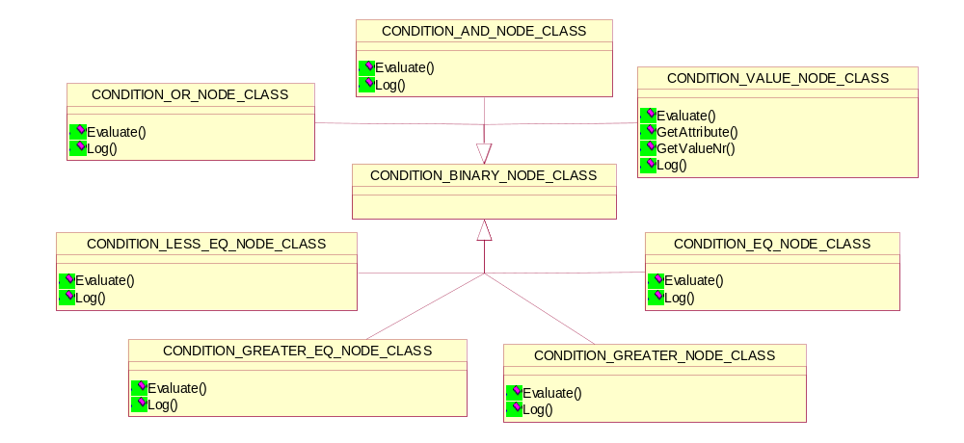
Figure 22 Relationship diagram

CONDITION_AND_NODE_CLASS
This class represents the conditions that contain two logically ANDed conditions.

Evaluate the condition
bool Evaluate(DCM_ATTRIBUTE_GROUP_CLASS*, DCM_ATTRIBUTE_GROUP_CLASS*, LOG_CLASS*);
This method first evaluates the left node then evaluates the right node.
Return value | Explanation
true | Only if both conditions evaluate true.
false | If any of the conditions evaluates false.

CONDITION_OR_NODE_CLASS
This class represents the conditions that contain two logically ORed conditions.

Evaluate the condition
bool Evaluate(DCM_ATTRIBUTE_GROUP_CLASS*, DCM_ATTRIBUTE_GROUP_CLASS*, LOG_CLASS*);
This method first evaluates the left node then evaluates the right node.
Return value | Explanation
true | If either of the conditions evaluate true.
false | If both the conditions evaluates false.

CONDITION_VALUE_NODE_CLASS
This class represents the condition, which refers an attribute. The attribute must have a specific value.

Evaluate the condition
bool Evaluate(DCM_ATTRIBUTE_GROUP_CLASS*, DCM_ATTRIBUTE_GROUP_CLASS*, LOG_CLASS*);
The evaluation of condition in the various operator classes described below.

Getting the referred attribute
DCM_ATTRIBUTE_CLASS *GetAttribute(DCM_ATTRIBUTE_GROUP_CLASS*, DCM_ATTRIBUTE_GROUP_CLASS*, LOG_CLASS*);
This function returns the attribute address found via the navigation.

Getting the value number indicated in definition file
UINT16 GetValueNr();

CONDITION_LESS_NODE_CLASS
This class represents the conditions that contain referred attribute and value nr in left node and constant value in right node. The “less” operator links both the nodes.

Evaluate the condition
bool Evaluate(DCM_ATTRIBUTE_GROUP_CLASS*, DCM_ATTRIBUTE_GROUP_CLASS*, LOG_CLASS*);
This method first gets the left node (referred attribute) value then gets the right node constant value defined in the condition. After getting both values it compares and returns the result.
Return value | Explanation
true | If any or specific value of referred attribute is smaller than the constant value indicated in the condition.
false | If value comparison returns false.

CONDITION_LESS_EQ_NODE_CLASS
This class represents the conditions that contain referred attribute and value nr in left node and constant value in right node. The “less equivalent” operator links both the nodes.

Evaluate the condition
bool Evaluate(DCM_ATTRIBUTE_GROUP_CLASS*, DCM_ATTRIBUTE_GROUP_CLASS*, LOG_CLASS*);
This method first gets the left node (referred attribute) value then gets the right node constant value defined in the condition. After getting both values it compares and returns the result.
Return value | Explanation
true | If any or specific value of referred attribute is smaller or equivalent than the constant value indicated in the condition.
false | If value comparison returns false.

CONDITION_EQ_NODE_CLASS
This class represents the conditions that contain referred attribute and value nr in left node and constant value in right node. The “equivalent” operator links both the nodes.

Evaluate the condition
bool Evaluate(DCM_ATTRIBUTE_GROUP_CLASS*, DCM_ATTRIBUTE_GROUP_CLASS*, LOG_CLASS*);
This method first gets the left node (referred attribute) value then gets the right node constant value defined in the condition. After getting both values it compares and returns the result.
Return value | Explanation
true | If any or specific value of referred attribute is equivalent than the constant value indicated in the condition.
false | If value comparison returns false.

CONDITION_GREATER_EQ_NODE_CLASS
This class represents the conditions that contain referred attribute and value nr in left node and constant value in right node. The “ greater equivalent” operator links both the nodes.

Evaluate the condition
bool Evaluate(DCM_ATTRIBUTE_GROUP_CLASS*, DCM_ATTRIBUTE_GROUP_CLASS*, LOG_CLASS*);
This method first gets the left node (referred attribute) value then gets the right node constant value defined in the condition. After getting both values it compares and returns the result.
Return value | Explanation
true | If any or specific value of referred attribute is greater or equivalent than the constant value indicated in the condition.
false | If value comparison returns false.

CONDITION_GREATER_ NODE_CLASS
This class represents the conditions that contain referred attribute and value nr in left node and constant value in right node. The “greater” operator links both the nodes.

Evaluate the condition
bool Evaluate(DCM_ATTRIBUTE_GROUP_CLASS*, DCM_ATTRIBUTE_GROUP_CLASS*, LOG_CLASS*);
This method first gets the left node (referred attribute) value then gets the right node constant value defined in the condition. After getting both values it compares and returns the result.
Return value | Explanation
true | If any or specific value of referred attribute is greater than the constant value indicated in the condition.
false | If value comparison returns false.

Condition Unary Node class
This class emulates the single conditions with logical operator Not and presence of particular attribute.

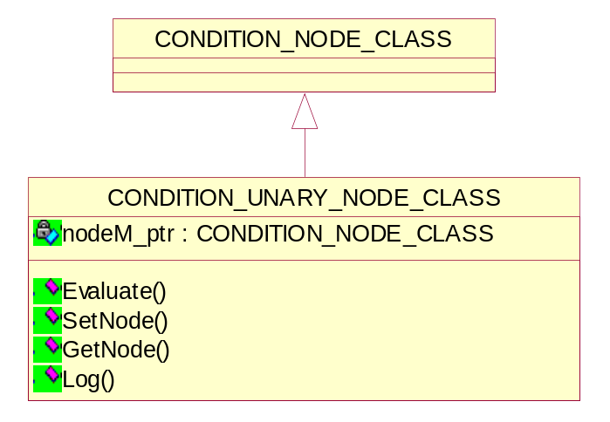
Figure 23 Condition Unary Node class diagram

Setting/Getting the condition node
void SetNode(CONDITION_NODE_CLASS *node_ptr);
CONDITION_NODE_CLASS* GetNode();

Evaluate the condition
bool Evaluate(DCM_ATTRIBUTE_GROUP_CLASS*, DCM_ATTRIBUTE_GROUP_CLASS*, LOG_CLASS*);
This method is implemented by derived classes.

Detail design of Condition Unary node class
The figure below shows the relationship between various classes derived from condition unary node class.
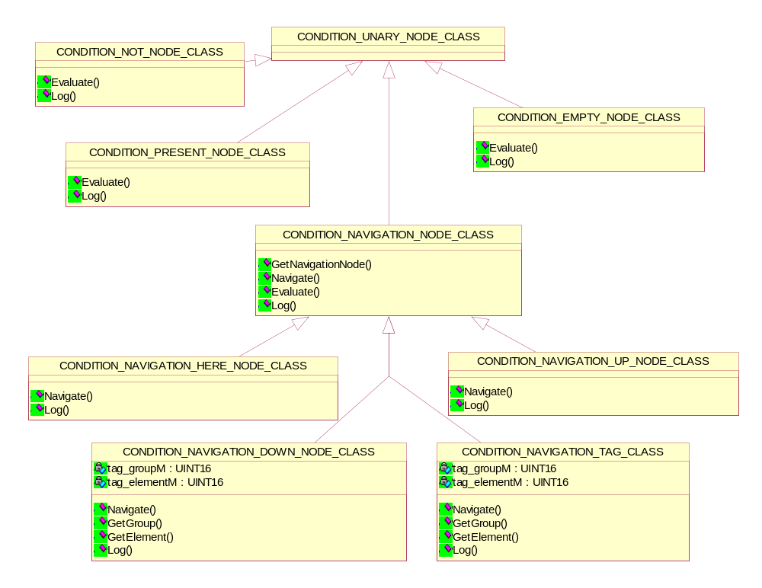
Figure 24 Relationship diagram

CONDITION_EMPTY_ NODE_CLASS
This class represents the conditions in which conditional attribute must be present if a referred attribute does not have any values.

Evaluate the condition
bool Evaluate(DCM_ATTRIBUTE_GROUP_CLASS*, DCM_ATTRIBUTE_GROUP_CLASS*, LOG_CLASS*);
This method first checks the presence of referred attribute and then value of the attribute. The attribute should not contain any value.
Return value | Explanation
true | If referred attribute doesn’t contain any value.
false | If attribute contain a valid value.

CONDITION_PRESENT_ NODE_CLASS
This class represents the conditions in which the conditional attribute must be present if the referred attribute is present in the object.

Evaluate the condition
bool Evaluate(DCM_ATTRIBUTE_GROUP_CLASS*, DCM_ATTRIBUTE_GROUP_CLASS*, LOG_CLASS*);
This method checks the presence of the referred attribute.
Return value | Explanation
true | If the referred attribute present.
false | If the referred attribute is not present.

CONDITION_NOT_ NODE_CLASS
This class represents the conditions, which reverses the logic of a condition. It can be used in combination with the EMPTY, PRESENT and VALUE conditions as described earlier.

Evaluate the condition
bool Evaluate(DCM_ATTRIBUTE_GROUP_CLASS*, DCM_ATTRIBUTE_GROUP_CLASS*, LOG_CLASS*);
This method the given condition and reverses it logically.
Return value | Explanation
true | If result is true.
false | If result is false.

CONDITION_NAVIGATION_ NODE_CLASS
This is the abstract class and used to navigate the up/down levels. A conditional attribute tag is used to define a condition then this attribute tag can take a “relative path” from the attribute being validated.
The relative path can take the following forms:
- ./<attribute tag>
The attribute tag is relative to the current position.
The attribute identified by the <attribute tag> must be found at the same “level” as the attribute being validated.
- [../]*[<sq attribute tag>/]*<attribute tag>
The attribute tag is relative to the “path” defined.
../ means a transition to the parent dataset/item that contains the attribute being validated – this is can be repeated 0 to n times. This can be viewed as a transition ‘up’ the dataset structure.
<sq attribute tag>/ means a transition to the sequence attribute identified by the <sq attribute tag> - this can be repeated 0 to n times. This can be viewed as a transition ‘down’ the dataset structure. The transition is always to done into the first item of any sequence encountered.

Evaluate the condition
bool Evaluate(DCM_ATTRIBUTE_GROUP_CLASS*, DCM_ATTRIBUTE_GROUP_CLASS*, LOG_CLASS*);
This method is implemented by derived classes.

Navigate to the node
virtual DCM_ATTRIBUTE_CLASS *Navigate(DCM_ATTRIBUTE_GROUP_CLASS*, DCM_ATTRIBUTE_GROUP_CLASS*, LOG_CLASS*) = 0;
This method is implemented by derived classes.

Get the navigated node
CONDITION_NAVIGATION_NODE_CLASS *GetNavigationNode();

CONDITION_NAVIGATION_HERE_NODE_CLASS
This class is used to navigate on the same level.

Navigate the node
DCM_ATTRIBUTE_CLASS *Navigate(DCM_ATTRIBUTE_GROUP_CLASS*, DCM_ATTRIBUTE_GROUP_CLASS*, LOG_CLASS*);
This method checks the presence of referred attribute on the same level and then gets the attribute. If attribute is present the result returns “true” otherwise it returns “false”.

CONDITION_NAVIGATION_UP_NODE_CLASS
This class is used to navigate on one level up.

Navigate the up node
DCM_ATTRIBUTE_CLASS *Navigate(DCM_ATTRIBUTE_GROUP_CLASS*, DCM_ATTRIBUTE_GROUP_CLASS*, LOG_CLASS*);
This method checks the presence of referred attribute on one level up and then gets the attribute. If attribute is present the result returns “true” otherwise it returns “false”.

CONDITION_NAVIGATION_DOWN_NODE_CLASS
This class is used to navigate on one level down.

Navigate the down node
DCM_ATTRIBUTE_CLASS *Navigate(DCM_ATTRIBUTE_GROUP_CLASS*, DCM_ATTRIBUTE_GROUP_CLASS*, LOG_CLASS*);
This method checks the presence of referred attribute on one level down and then gets the attribute. If attribute is present the result returns “true” otherwise it returns “false”.

Getting the group
UINT16 GetGroup();

Getting the element
UINT16 GetElement();

CONDITION_NAVIGATION_TAG_CLASS
This class searches the attribute in the object through the given tag.

Navigate the down node
DCM_ATTRIBUTE_CLASS *Navigate(DCM_ATTRIBUTE_GROUP_CLASS*, DCM_ATTRIBUTE_GROUP_CLASS*, LOG_CLASS*);
This method first checks the presence of referred attribute in the first object and then checks the presence in another object. If the attribute is present then it returns “true” else “false”.

Getting the group
UINT16 GetGroup();

Getting the element
UINT16 GetElement();

Condition Leaf class
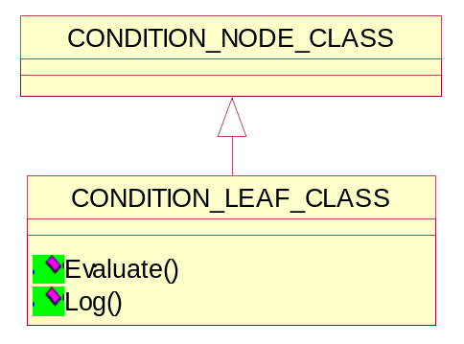
Figure 25 Condition Leaf class diagram

Evaluate the leaf
bool Evaluate(DCM_ATTRIBUTE_GROUP_CLASS*, DCM_ATTRIBUTE_GROUP_CLASS*, LOG_CLASS*);
This method is implemented by derived classes.

Detail design of Condition Leaf class
The figure below shows the relationship between various classes derived from condition leaf class.

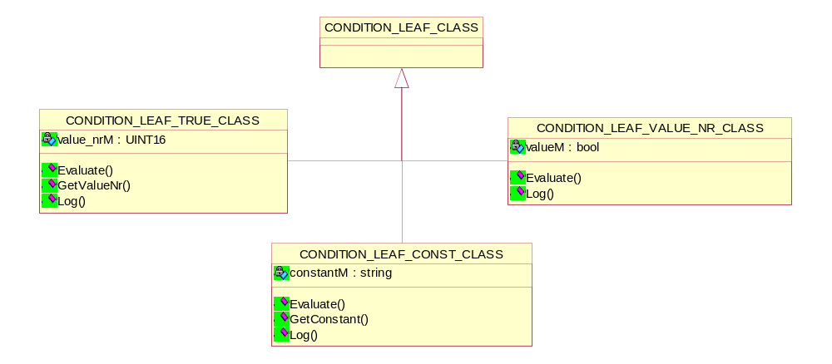
Figure 26 Relationship diagram

CONDITION_LEAF_CONST_CLASS
This class represents the textual conditions. Sometimes it is not possible to specify a condition in Boolean logic. Then it is possible to specify a textual condition, just for information to the user and to be aware of the condition. The condition can be specified a an ordinary string, within double ' " ' quotes.
The condition will not be evaluated but will be printed to the validation results.

Evaluate the leaf
bool Evaluate(DCM_ATTRIBUTE_GROUP_CLASS*, DCM_ATTRIBUTE_GROUP_CLASS*, LOG_CLASS*);
This method returns the default “true” result.

CONDITION_LEAF_VALUE_NR_CLASS
This class represents the value nr. The condition will not be evaluated but will be printed to the validation results.

Evaluate the leaf
bool Evaluate(DCM_ATTRIBUTE_GROUP_CLASS*, DCM_ATTRIBUTE_GROUP_CLASS*, LOG_CLASS*);
This method returns the default “true” result.

CONDITION_LEAF_TRUE_CLASS
This class represents the Boolean.

Evaluate the leaf
bool Evaluate(DCM_ATTRIBUTE_GROUP_CLASS*, DCM_ATTRIBUTE_GROUP_CLASS*, LOG_CLASS*);
This method returns true if Boolean is “true” or returns “false”.

Appendix A Definition File Format Reference
The Definition File format can formally be described in Backus-Naur Form (BNF).
With BNF notation the syntactic specification of a grammar can be described. A grammar involves four quantities: terminals, nonterminals, a start symbol and productions.
The basic symbols of which strings in the language are composed are called terminals. Terminals are upper-case letters, digits, operator or punctuation symbols such as '(', ')' or ','.
Non-terminals are special symbols that denote sets of strings (or syntactic categories). Nonterminals are lower-case letters enclosed in brackets.
One non-terminal is selected as the start symbol (<language>) and it denotes the language in which we are truly interested.
The productions define ways in which the syntactic categories may be built up from on another and from the terminals. Each production consists of a nonterminal, followed by a symbol '::=', followed by a sequence of non-terminals and terminals. The vertical bar symbol '|' means logical OR.

TOP LEVEL DEFINITIONS

<definitiongrammar> ::= <definitioncomponents>

<definitioncomponents> ::= <definition>
| <definitioncomponents> <definition>

<definition> ::= <define>
| <displayformat>
| <namemapping>
| <fileindex>

<define> ::= DEFINE <definitions> ENDDEFINE

<definitions> ::= <systemdef>
| <metasopclassdef>
| <commanddef>
| <commandioddef>
| <macrodef>

SYSTEM DEFINITION

<systemdef> ::= SYSTEM <system name> <system version> <ae definition>

<ae definition> ::= <ae name> <ae version>

<ae name> ::= <string>

<ae version> ::= <string>

METASOPCLASS DEFINITION

<metasopclassdef> ::= METASOPCLASS <beginmetasopclassdef> <sopclassdeflist>

<beginmetasopclassdef> ::= <metasopclassuid> <metasopclassname>

<metasopclassuid> ::= <string>

<metasopclassname> ::= <string>

<sopclassdeflist> ::= <sopclassdef>
| <sopclassdeflist> <sopclassdef>

COMMAND DEFINITION

<commanddef> ::= <dimsecmddef> <attributedeflist>

<dimsecmddef> ::= <dimsecmd>

<dimsecmd> ::= <command>

MACRO DEFINITION

<macrodef> ::= MACRO <macroname> <attributedeflist>

<macroname> ::= <string>

COMMAND IOD DEFINITION

<commandioddef> ::= <dimsecmddef> <iodname> <iodcontentdef>

<iodname> ::= <string>

<iodcontentdef> ::= <sopclassdef> <moduledeflist>

SOPCLASS DEFINITION

<sopclassdef> ::= SOPCLASS <sopclassuid> <sopclassname>

<sopclassuid> ::= <string>

<sopclassname> ::= <string>

MODULE DEFINITION

<moduledeflist> ::= <moduledef>
| <moduledeflist> <moduledef>

<moduledef> ::= <modulenamedef> <attributedeflist>

<modulenamedef> ::= MODULE <modulename> <moduleusage>

<modulename> ::= <string>

<moduleusage> ::= <usage> <condition>

<attributedeflist> ::= <attributedef>
| <attributedeflist> <attributedef>

ATTRIBUTE DEFINITION

<attributedef> ::= ( <attributetagdef> , <attributetype> , <attributevaluedef> )
<attributename> <condition>
| <macroreference>

<attributetagdef> ::= <attributetag>

<attributetag> ::= <hex>

<attributetype> ::= <integer>
| <type>

<attributename> ::= <string>

<attributevaluedef> ::= <sequencevaluedef>
| <othervaluedef>

<sequencevaluedef> ::= <sequenceintro> <itemattributedeflist>
| <sequenceintro>

<sequenceintro> ::= SQ , <attributevm> ,

<itemattributedeflist> ::= <itemattributedef>
| <itemattributedeflist> <itemattributedef>

<itemattributedef> ::= > <attributedef>

<attributevm> ::= <integer>
| <integer> : <integer>
| <integer> : <integer>
| <string>
| n

<attributevr> ::= <vr>
| <vr> / <vr>

<othervaluedef> ::= <attributevr> , <attributevm> <valuesdeflist>

<attributevm> ::= <integer>
| <integer> : <integer>
| <integer> : n
| n

<valuesdef> ::= ε
| , <firstvaluesdef>
| , <firstvaluesdef> , <othervaluesdeflist>

<firstvaluesdef> ::= <valuetype> , <valueslist>

<othervaluesdeflist> ::= <othervaluesdef>
| <othervaluesdeflist> , <othervaluesdef>

<othervaluesdef> ::= <valuetype> , <valueslist>
| <valueslist>

<valueslist> ::= <value>
| <valueslist> | <value>

<value> ::= <string>
| <hex>
| <integer>

<valuetype> ::= D
E

<macroreference> ::= INCLUDEMACRO <macroname> <macrocondition>

<macrocondition> ::= <condition>

CONDITION DEFINITION

<condition> ::= ε
| : <condexpr>

<condexpr> ::= <expr1>
| <condexpr> OR <expr1>

<expr1> ::= <expr2>
| WEAK ( <expr2> )

<expr2> ::= <simpleexpr>
| <expr2> AND <simpleexpr>

<simpleexpr> ::= PRESENT <searchdirection> <attributetag>
| EMPTY <attributetag>
| VALUE <attributetag> <valuenr> <operator> <condvalue>
| NOT <simpleexpr>
| ( <condexpr> )

<searchdirection> ::= ε
| HERE

<valuenr> ::= ε
| <integer>

<condvalue> ::= <string>

<operator> ::= =
| <
| >
| <=
| >=

SPECIAL DEFINITIONS

<displayformat> ::= <imagedisplayformat>
| <annotationdisplayformatid>

<imagedisplayformat> ::= IMAGE-DISPLAY-FORMAT <string> <integer>

<annotationdisplayformatid> ::= ANNOTATION-DISPLAY-FORMAT-ID <string> <integer>

<fileindex> ::= IDX : <idxuid> <idxfilename>

<idxuid> ::= <string>

<idxfilename> ::= <string>

<namemapping> ::= MAPNAME <mapdimsecmd> <sourcename> <targetname> ;
| MAPNAME <sourcename> <targetname> ;

<mapdimsecmd> ::= <commandfiled>

<sourcename> ::= <string>

<targetname> ::= <string>

